Observations in the garden

Comment | Photos
This plant looks waterlogged, kind of like a succulent. I think it's sage. The funny thing is that the leaves look like a cat's tongue. | 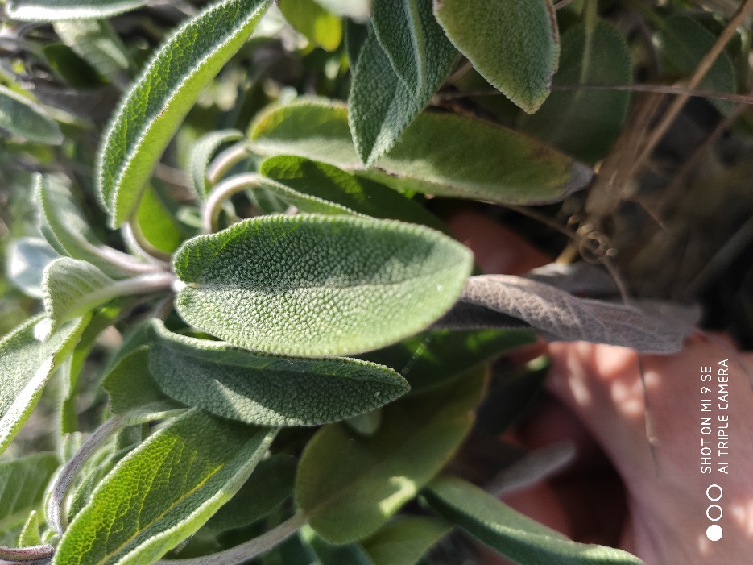
Here is some chard. This one is red, we often know its green version better. It looks a bit coarse, which is perhaps why some people are reluctant to cook it. However, it can be eaten in a gratin or even alone with cherry tomatoes and a drizzle of olive oil. | 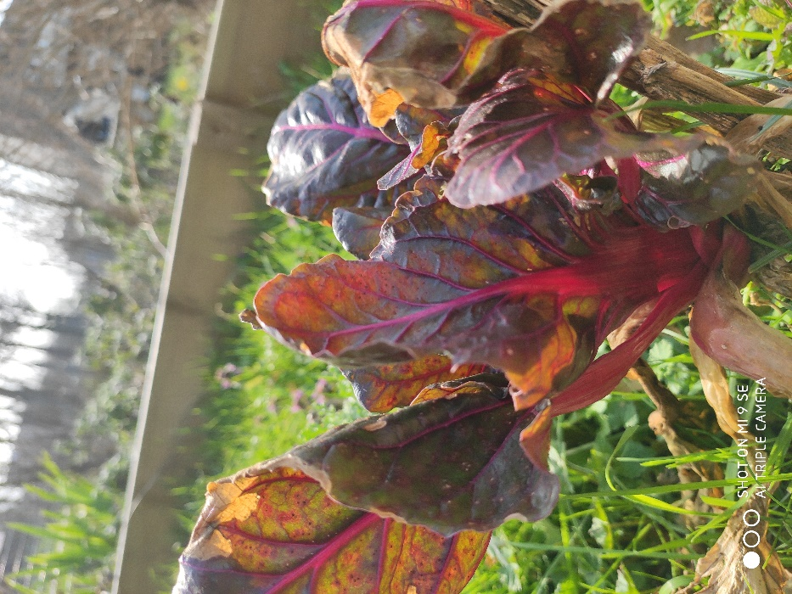
Here is a flower, it is an anemone. I find it eye-catching with its pretty purplish color, especially when the weather is nice. For me, it plays in the category of the most beautiful plants in the garden. | 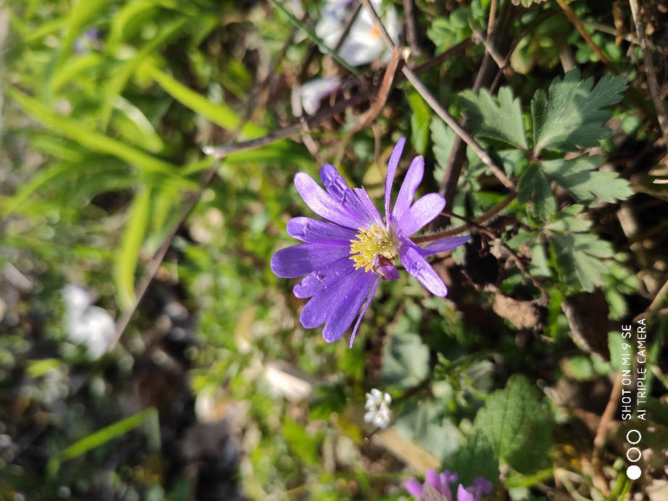
I took a picture of another plant that caught my eye: a crocus with yellow flowers. The flowers are located quite close to the ground which is not usual for flowers. If you look closely, the leaves are quite elegant too. We can observe a white border all along. As a bonus, if we dig a little around, we can see the bulb! | 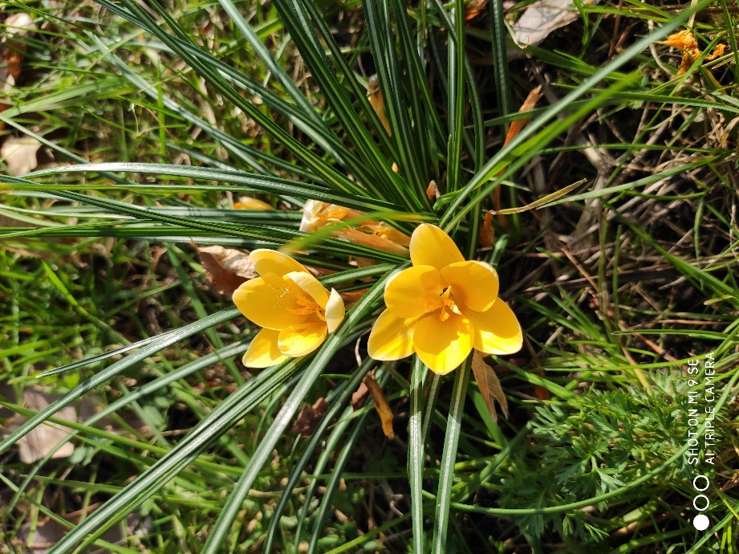
Here is a picture after planting an Italian immortelle. This plant smells exactly like curry. If you didn't know better, you would have quickly realized it when you planted it! When it blooms, it gives a beautiful explosion of yellow flowers. You can also see the tools I used for planting, including gloves (there were nettles...). | 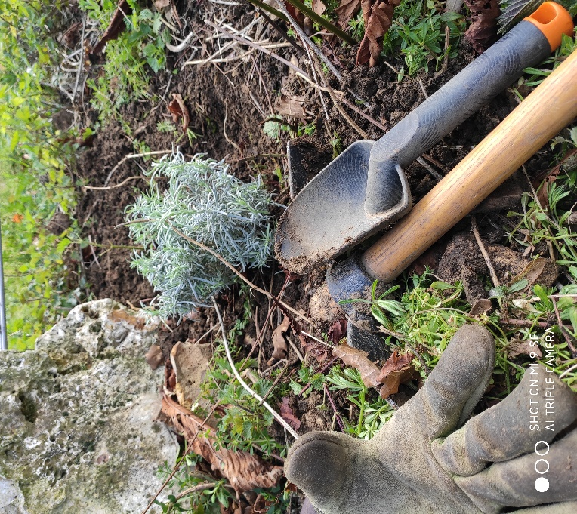
Here is a set of small pots to plant seeds in. You can also see Medhi-Lou's hand moistening the soil in the pots. | 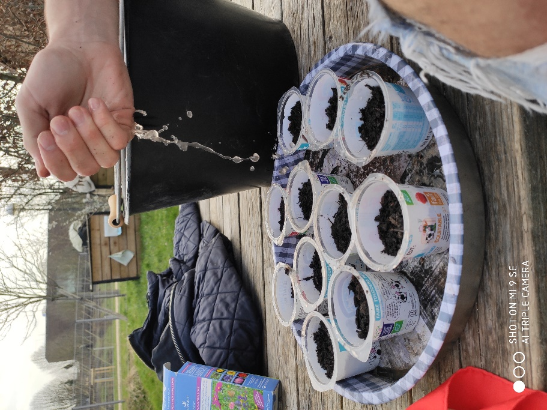
Sometimes the garden needs to be cleaned up a bit, too. We make room for living plants by cutting down dead ones. It is necessary to know how to handle the pliers but Guillaume is a master in this art. | 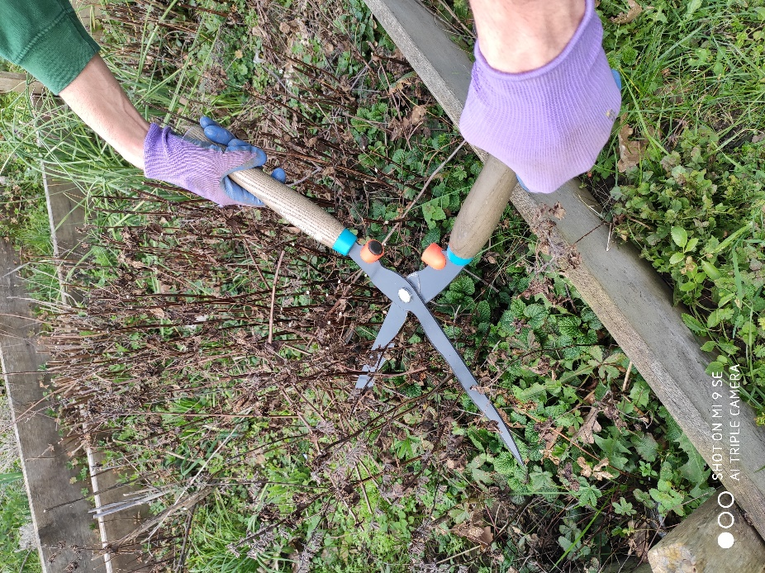
On this picture, you can see a permaculture bed. The principle is to cultivate several species in order to recreate a small ecosystem. This increases the interaction between plants and thus favors their development. Often, it is used to optimize the space by superimposing different layers of plants. In this case, the plants that need the least water are placed at the top and the thirstiest at the bottom. | 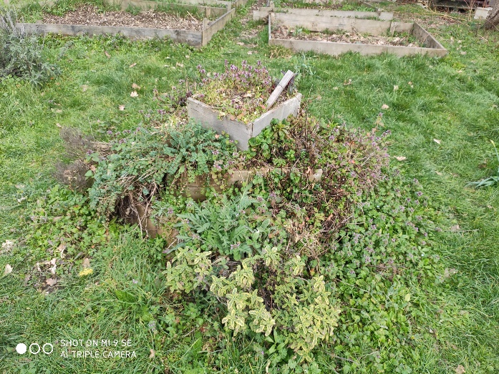
We see here a small box where garlic is grown. You can see a picture of it at the bottom left. Raphaël and Marion are planting carrots of all colors. For that, they made small rows between the rows of garlic, dug small holes with their fingers and put the seeds there before humifying the whole. | 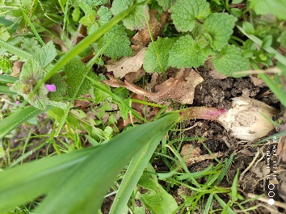  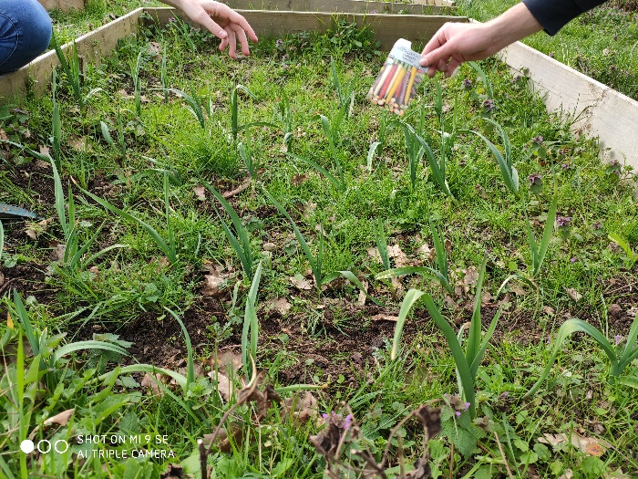
Here is a close-up of a daffodil. It too plays in the categories of the most beautiful flowers in the garden. What strikes you at first sight is obviously its very pronounced yellow color. But, if you take a closer look, you realize that the flower is finely chiseled! It even looks like a kind of crown. It is definitely a great lady of the garden. | 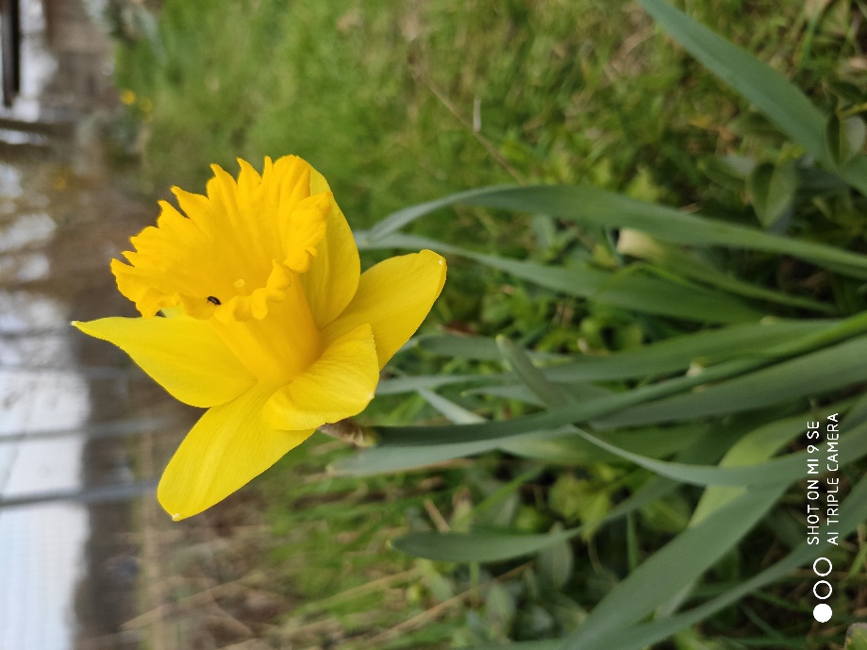
We find here the small pots filled with compost of which Medhi-Lou took good care. Seeds have been placed in them and a little sign has been put up to let you know where what is. Note the effort to have kept the yogurt pots for the occasion! | 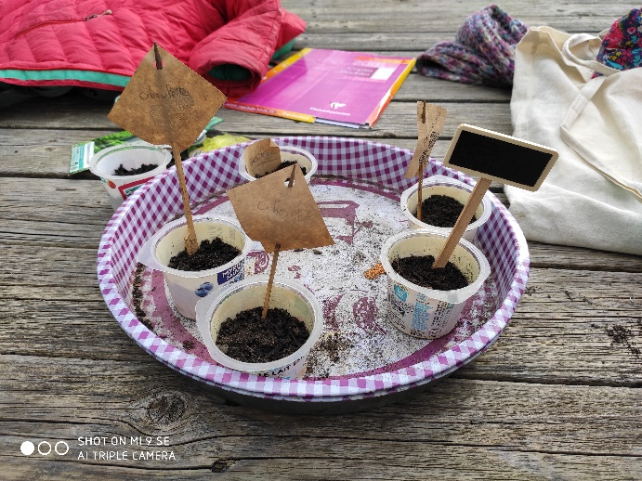
Here, you can admire another crocus. This one does not have yellow flowers but white ones tinted with purple at the base. You can also see that the pistil is a very pronounced orange. All these colors in harmony, that's what makes it my favorite flower of the garden! | 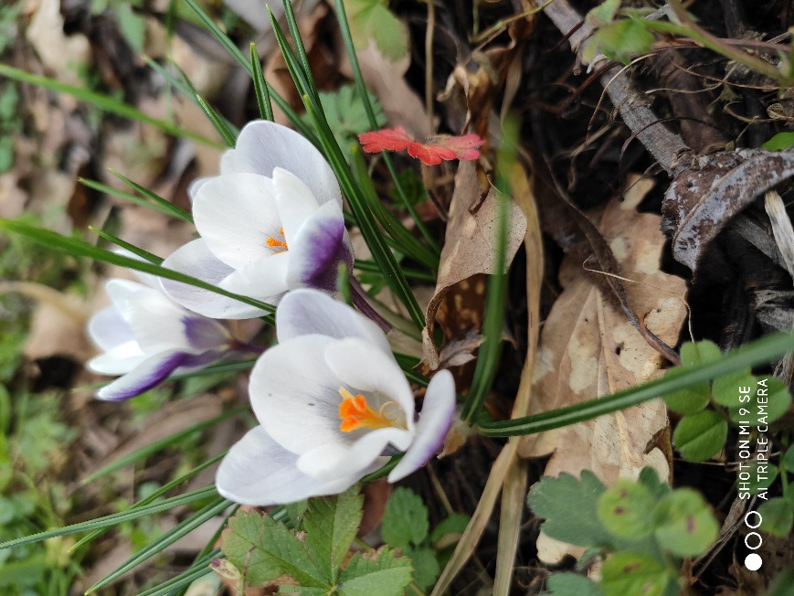
I had to take a more general picture of the garden. Isn't it beautiful all the same? In the background, you can see the tank that serves as a water reservoir by collecting the water that falls from the roof of the hut. It is very practical (when it is full...). You can also see the boxes and some perennials in front. | 